**­­­Supplementary Information (SI)**

**Unprecedented high probe-reported polarity of deep eutectic solvents composed of lanthanide salts and urea**

Anushis Patra, Vaishali Khokhar and Siddharth Pandey*

Department of Chemistry, Indian Institute of Technology Delhi, Hauz Khas,

New Delhi - 110016, India.

* To whom correspondence should be addressed. E-mail: [sipandey@chemistry.iitd.ac.in](mailto:sipandey@chemistry.iitd.ac.in);

Phone: +91-11-26596503; Fax: +91-11-26581102.

**Table of Contents**

**Page No.**

**Table S1 S3**

**Table S2 S4-S5**

**Table S3 S6**

**Figure S1 S7**

**Figure S2 S8**

**Figure S3 S9**

**Figure S4 S10**

**Figure S5 S11**

**Figure S6 S12**

**Table S1.** Absorbance wavelength ($λ_{max}^{ab}$/nm) of 20 μM DENA and 20 μM NA dissolved in Ln : U based deep eutectic solvent at room temperature.

|  |  |  |  |
| --- | --- | --- | --- |
| DES | Ratio | DENA | NA |
| La : U | 1 : 3 | 448 | 393 |
| 1 : 4 | 447 | 392 |
| 1 : 5 | 445 | 392 |
| 1 : 6 | 442 | 389 |
| 1 : 7 | 441 | 392 |
|  |  |  |  |
| Ce : U | 1 : 3.5 | 446 | 401 |
| 1 : 4 | 446 | 400 |
| 1 : 5 | 444 | 400 |
| 1 : 6 | 442 | 400 |
| 1 : 7 | 439 | 398 |
|  |  |  |  |
| Gd : U | 1 : 2 | 452 | 392 |
| 1 : 3 | 447 | 391 |
| 1 : 4 | 445 | 391 |
| 1 : 5 | 444 | 391 |
| 1 : 6 | 442 | 391 |
| 1 : 7 | 441 | 390 |

**Table S2.** Recovered excited-state intensity decay parameters for pyranine (${}_{em }$ = 450 nm, 515nm; excitation with a 404 nm violet-laser diode) dissolved in the Ln : U based DES at room temperature by using global fit.

|  |  |  |  |  |  |  |  |
| --- | --- | --- | --- | --- | --- | --- | --- |
| **Ratio** | **λem (nm)** | **τ1 (ns) (α1)** | | **τ2 (ns) (α2)** | | **χ2** | |
| **La : U** | | | | | | | |
| 1 : 3 | 450 | | 1.99 (1.00) | |  | | 1.15 | |
|  |  | 1.32 (0.67) | | 2.43 (0.33) | | 0.69 | |
|  |  |  | |  | |  | |
|  | 515 | 1.99 (1.00) | |  | | 1.06 | |
|  |  | 1.32 (0.40) | | 2.43 (0.60) | | 0.75 | |
|  |  |  | |  | |  | |
| 1 : 4 | 450 | 2.22 (1.00) | |  | | 1.63 | |
|  |  | 1.25 (0.60) | | 2.53 (0.40) | | 0.75 | |
|  |  |  | |  | |  | |
|  | 515 | 2.22 (1.00) | |  | | 1.40 | |
|  |  | 1.25 (0.11) | | 2.53 (0.89) | | 0.76 | |
|  |  |  | |  | |  | |
| 1 : 5 | 450 | 2.50 (1.00) | |  | | 2.50 | |
|  |  | 1.41(0.64) | | 2.74 (0.36) | | 0.68 | |
|  |  |  | |  | |  | |
|  | 515 | 2.50 (1.00) | |  | | 2.23 | |
|  |  | 1.41 (−0.15) | | 2.74 (0.85) | | 0.87 | |
|  |  | | | | | | |
| 1 : 6 | 450 | 2.79 (1.00) | |  | | 4.94 | |
|  |  | 1.57 (0.74) | | 3.10 (0.26) | | 0.90 | |
|  |  |  | |  | |  | |
|  | 515 | 2.79 (1.00) | |  | | 3.71 | |
|  |  | 1.57 (−0.21) | | 3.10 (0.79) | | 0.99 | |
|  |  |  | |  | |  | |
| 1 : 7 | 450 | 2.95 (1.00) | |  | | 6.32 | |
|  |  | 1.68 (0.79) | | 3.39 (0.21) | | 0.94 | |
|  |  |  | |  | |  | |
|  | 515 | 2.95 (1.00) | |  | | 5.69 | |
|  |  | 1.68 (−0.21) | | 3.39 (0.79) | | 1.00 | |
| **Ce : U** | | | | | | | |
| 1 : 3.5 | 450 | 1.79 (1.00)  0.73 (0.53) | | 2.04 (0.47) | | 1.29  0.70 | |
|  |  |  | |  | |  | |
|  | 515 | 1.79 (1.00)  0.73 (0.25) | | 2.04 (0.75) | | 1.22  0.84 | |
|  |
|  |  |  | |  | |  | |
| 1 : 4 | 450 | 2.05 (1.00) | |  | | 2.68 | |
|  |  | 0.97 (0.62) | | 2.26 (0.38) | | 0.82 | |
|  |  |  | |  | |  | |
|  | 515 | 2.05 (1.00) | |  | | 2.05 | |
|  |  | 0.97 (−0.11) | | 2.26 (0.89) | | 0.94 | |
|  |  |  | |  | |  | |
| 1 : 5 | 450 | 2.35 (1.00) | |  | | 4.18 | |
|  |  | 1.24 (0.69) | | 2.58 (0.31) | | 0.94 | |
|  |  |  | |  | |  | |
|  | 515 | 2.35 (1.00) | |  | | 3.05 | |
|  |  | 1.24 (−0.24) | | 2.58 (0.76) | | 0.84 | |
|  |  |  | |  | |  | |
| 1 : 6 | 450 | 2.68 (1.00) | |  | | 6.02 | |
|  |  | 1.39 (0.77) | | 2.93 (0.23) | | 0.80 | |
|  |  |  | |  | |  | |
|  | 515 | 2.68 (1.00) | |  | | 3.92 | |
|  |  | 1.39 (−0.25) | | 2.93 (0.75) | | 0.87 | |
|  |  |  | |  | |  | |
| 1 : 7 | 450 | 2.93 (1.00) | |  | | 8.67 | |
|  |  | 1.62 (0.83) | | 3.20 (0.17) | | 0.92 | |
|  |  |  | |  | |  | |
|  | 515 | 2.93 (1.00) | |  | | 5.86 | |
|  |  | 1.62 (−0.30) | | 3.20 (0.70) | | 0.99 | |
| **Gd : U** | | | | | | | |
| 1 : 2 | 450 | 1.65 (1.00) | |  | | 1.24 | |
|  | 0.80 (0.56) | | 2.01 (0.44) | | 0.83 | |
|  |  |  | |  | |  | |
|  | 515 | 1.65 (1.00) | |  | | 1.09 | |
|  |  | 0.80 (0.47) | | 2.01 (0.53) | | 0.79 | |
|  |  | | | | | | |
| 1 : 3 | 450 | 1.97 (1.00) | |  | | 1.18 | |
|  |  | 0.73 (0.49) | | 2.22 (0.51) | | 0.66 | |
|  |  |  | |  | |  | |
|  | 515 | 1.97 (1.00) | |  | | 1.09 | |
|  |  | 0.73 (0.28) | | 2.22 (0.72) | | 0.74 | |
|  |  |  | |  | |  | |
| 1 : 4 | 450 | 2.24 (1.00) | |  | | 1.55 | |
|  |  | 1.24 (0.57) | | 2.56 (0.43) | | 0.86 | |
|  |  |  | |  | |  | |
|  | 515 | 2.24 (1.00) | |  | | 1.22 | |
|  |  | 1.24 (0.20) | | 2.56 (0.80) | | 0.75 | |
|  |  |  | |  | |  | |
| 1 : 5 | 450 | 2.31 (1.00) | |  | | 1.37 | |
|  |  | 0.96 (0.46) | | 2.54 (0.54) | | 0.77 | |
|  |  |  | |  | |  | |
|  | 515 | 2.31 (1.00) | |  | | 1.02 | |
|  |  | 0.96 (0.16) | | 2.54 (0.84) | | 0.74 | |
|  |  |  | |  | |  | |
| 1 : 6 | 450 | 2.69 (1.00) | |  | | 3.20 | |
|  |  | 1.62 (0.66) | | 2.92 (0.34) | | 0.91 | |
|  |  |  | |  | |  | |
|  | 515 | 2.69 (1.00) | |  | | 2.69 | |
|  |  | 1.62 ( −0.19) | | 2.92 (0.81) | | 1.01 | |
|  |  |  | |  | |  | |
| 1 : 7 | 450 | 2.89 (1.00) | |  | | 3.78 | |
|  |  | 1.77 (0.73) | | 3.18 (0.27) | | 0.89 | |
|  |  |  | |  | |  | |
|  | 515 | 2.89 (1.00) | |  | | 3.46 | |
|  |  | 1.77 (−0.20) | | 3.18 (0.80) | | 1.14 | |

**Table S3.** FTIR absorbance band maxima of urea, Gd(NO3)3.6H2O, and DES (Gd : U) at 1 : 2 molar ratios.

|  |  |  |
| --- | --- | --- |
| IR Absorbance Band Maxima of Urea (cm-1) | IR Absorbance Band Maxima of Gd(NO3)3.6H2O (cm-1) | IR Absorbance Band Maxima of  (Gd : U :: 1 : 2) DES  (cm-1) |
| 560 |  | 579, 528 |
| 788 |  | 776 |
|  | 816 | 826 |
|  | 1326 | Shoulder at 1330 |
|  | 1385 | Broad peak at 1393 |
| 1465 | 1480 | 1475 |
| 1600 |  | 1590 |
| 1625 | 1632 | 1640 |
| 3260 |  | Shoulder at 3226 |
|  | Shoulder at 3216 | Shoulder at 3226 |
| 3345 | Broad peak at 3390 | 3360 |
| 3448 | 3475 |

**Figure S1.** Absorbance spectra of 20 μM DENA and 20 μM NA dissolved in Ln : U based DESs at room temperature.

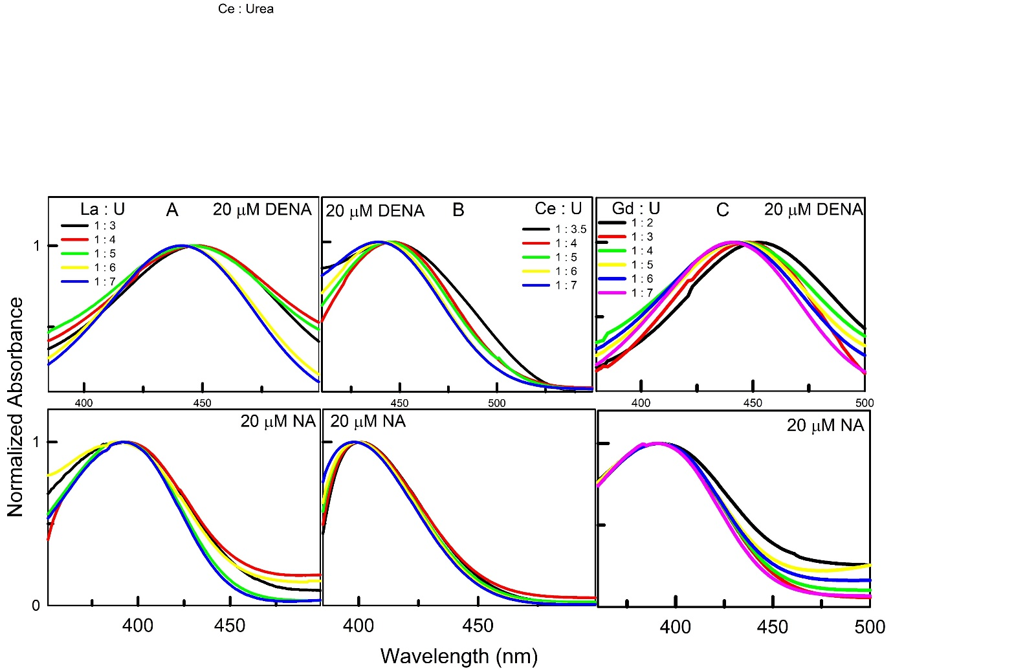

**Figure S2.** 13C NMR spectra of 250 mM PyO within La : U at 1 : 4 (**Panel A**), 1 : 5 (**Panel B**) and 1 : 6 (**Panel C**) molar ratios.

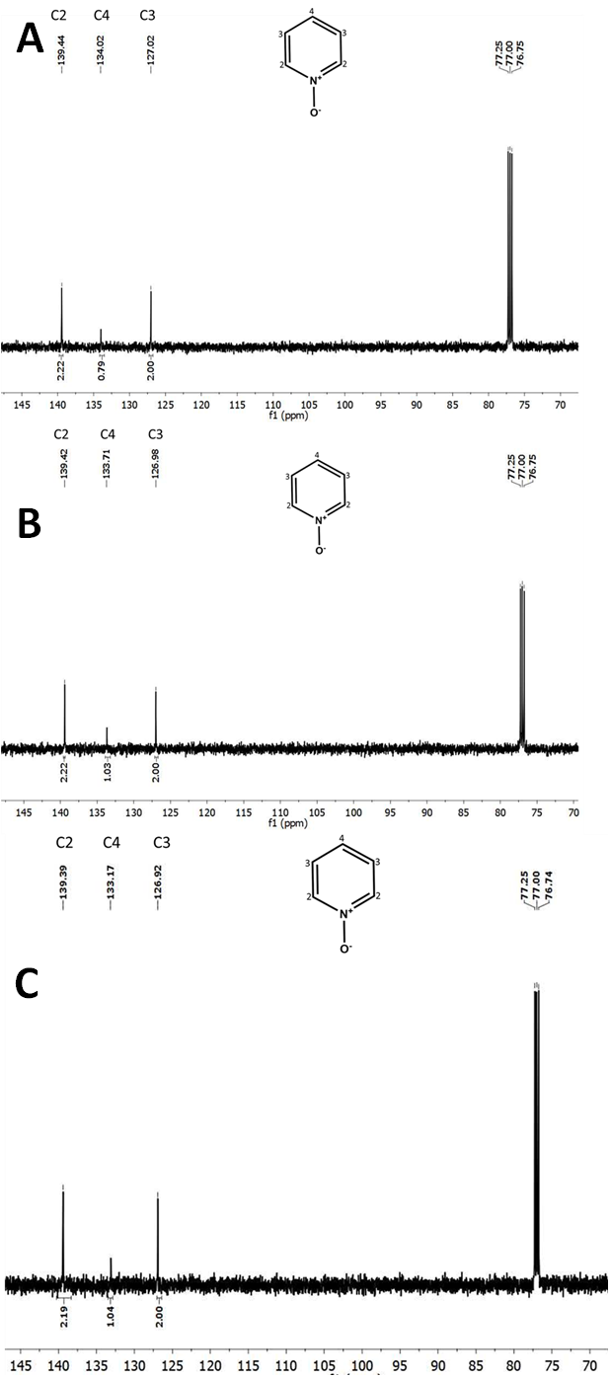

**Figure S3.** Fluorescence emission spectra of 25μm PyCHO ( $λ_{ex}=406 nm)$ dissolved in Ln : U based DESs at room temperature.

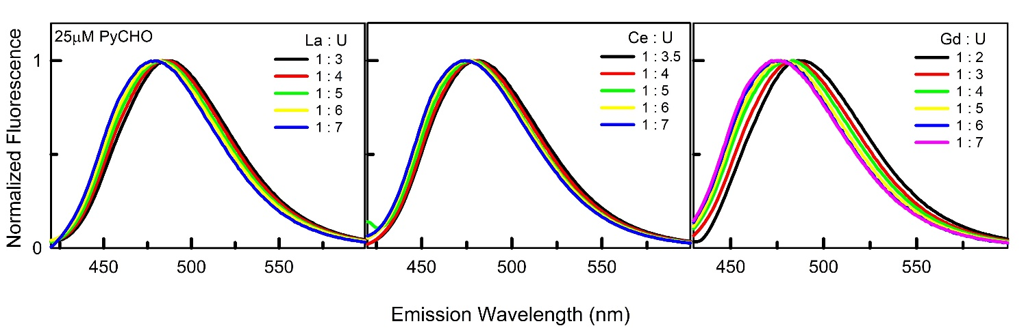

**Figure S4.** Absorbance spectra of 10μM Nile red andFluorescence excitation spectra of 25μM Nile red dissolved in Ce : U (panel A) and Gd : U (panel B) based DESs at room temperature.

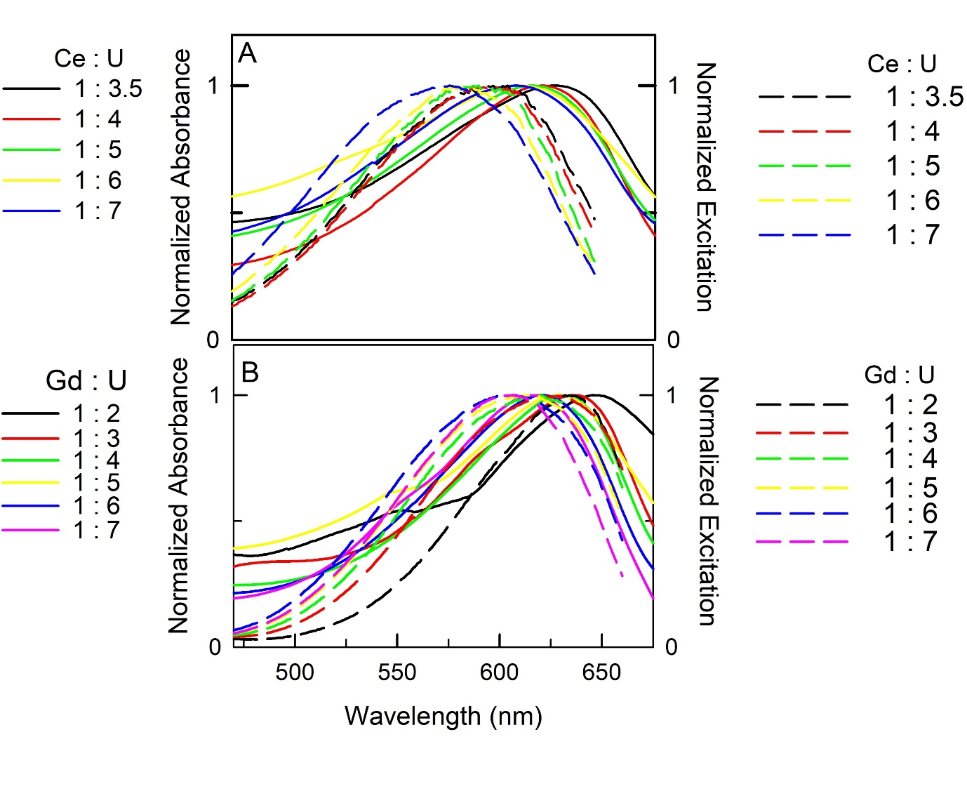

**Figure S5.** RLS spectra of Nile red with variation of concentration dissolved in Ln : U ( 1 : 7) based DESs at room temperature.

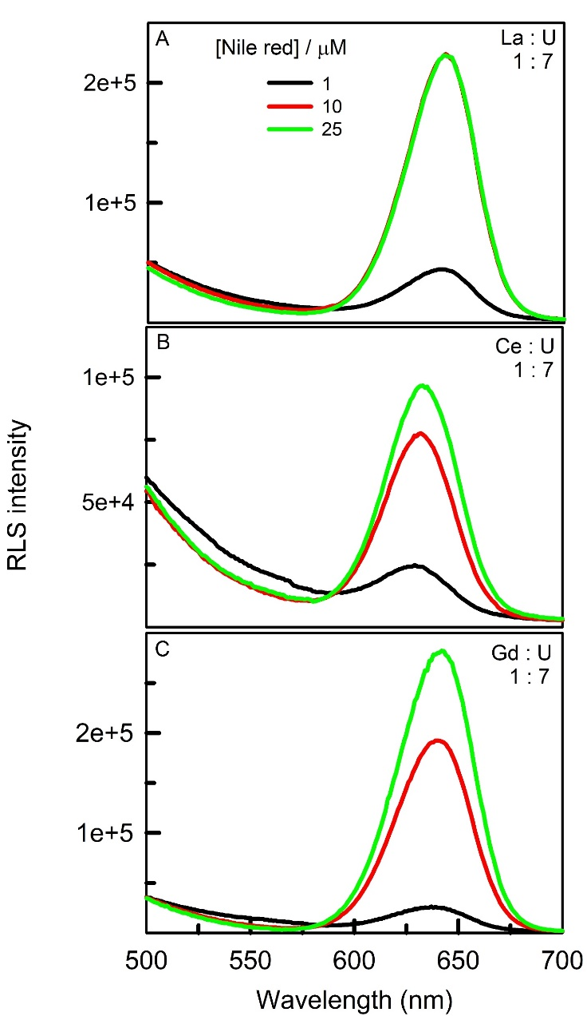

**Figure S6.** Emission spectra of 25 μM pyranine ( $λ_{ex}=406 nm)$ dissolved in Ln : U based DESs at room temperature.

